ER {Endoplasmic Reticulum}
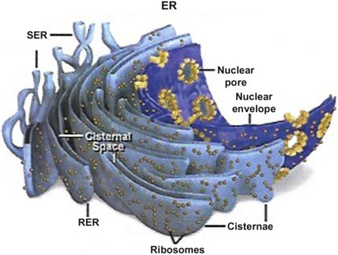

The endoplasmic reticulum (ER) is a network of interconnected membranes within eukaryotic cells, playing a crucial role in protein and lipid synthesis, modification, and transport. It exists in two forms: rough endoplasmic reticulum (RER), which is studded with ribosomes and involved in protein synthesis, and smooth endoplasmic reticulum (SER), which lacks ribosomes and is involved in lipid synthesis and other functions.
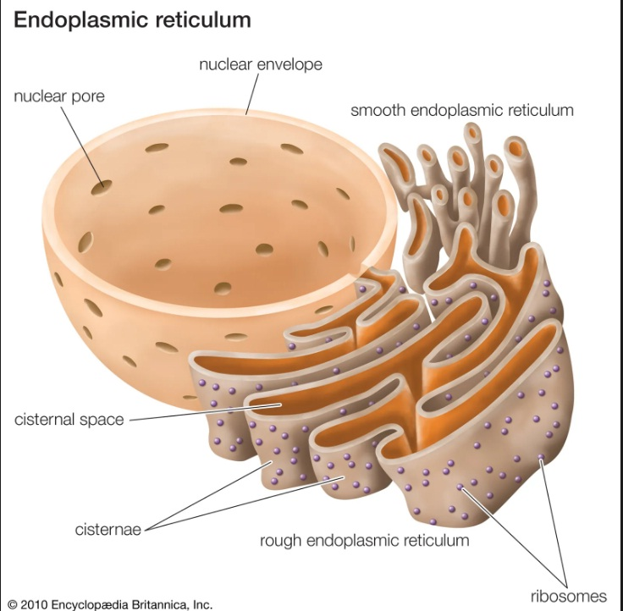
Elaboration:
- Structure:
The ER is a continuous network of membrane-bound tubules and flattened sacs (cisternae) that extends from the nuclear membrane throughout the cytoplasm.
- Rough Endoplasmic Reticulum (RER):
The RER is characterized by the presence of ribosomes on its outer surface, which are responsible for protein synthesis. Proteins synthesized on the RER are often destined for other organelles, the cell membrane, or secretion outside the cell.
- Smooth Endoplasmic Reticulum (SER):
The SER lacks ribosomes and is involved in a variety of functions, including lipid synthesis (steroid hormones, phospholipids), detoxification of drugs and toxins, and the release of calcium ions for muscle contraction and nerve function.
- Functions:
The ER performs various functions, including:
  - Protein Synthesis: The RER is the primary site of protein synthesis, especially for proteins destined for secretion or insertion into the cell membrane.
  - Lipid Synthesis: The SER is involved in the synthesis of various lipids, including steroids, phospholipids, and cholesterol.
  - Detoxification: The SER can help detoxify harmful substances in the body.
  - Calcium Storage and Release: The ER can store and release calcium ions, which are crucial for muscle contraction and nerve function.
  - Protein Folding and Modification: The ER plays a role in protein folding and modification, ensuring proteins are properly shaped and functional.
- Relationship to Other Organelles:
The ER is connected to the nuclear envelope and other organelles, including the Golgi apparatus, allowing for the efficient movement and modification of proteins and lipids.
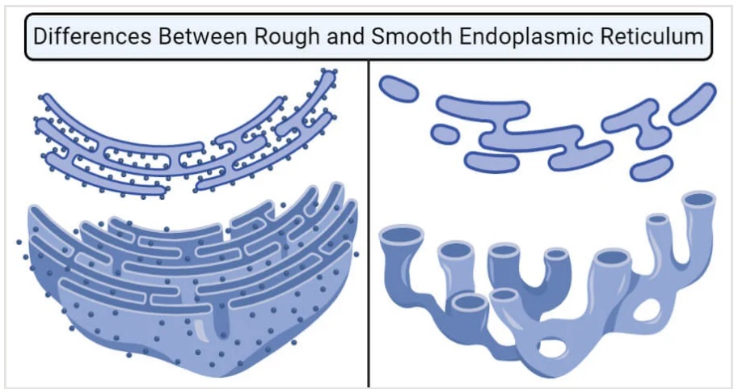

RER {Rough Endoplasmic Reticulum}

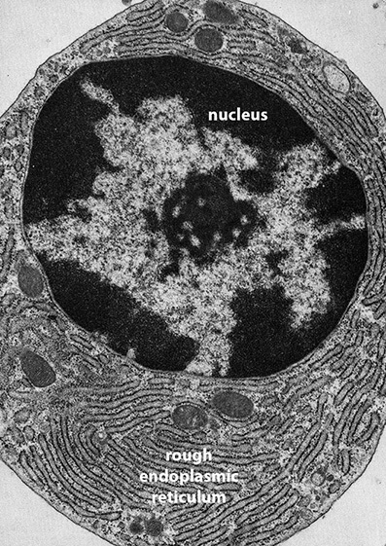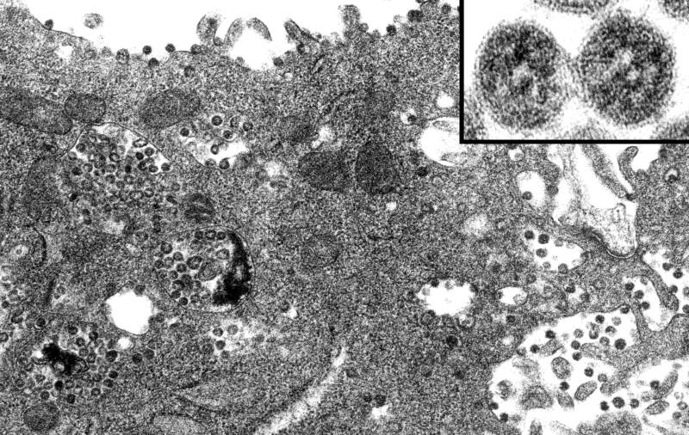

The rough endoplasmic reticulum (RER) is a network of membrane-bound sacs and tubules found in the cytoplasm of eukaryotic cells. It's characterized by ribosomes attached to its surface, giving it a "rough" appearance. The RER plays a crucial role in protein synthesis, folding, and modification, especially for proteins destined for secretion or incorporation into other cell membranes.
Here's a more detailed explanation:
Structure:
- Membrane Sheets:
The RER consists of flattened, interconnected sacs called cisternae, which extend throughout the cytoplasm, often near the nucleus.
- Ribosomes:
Ribosomes, the protein synthesis machinery, are attached to the outer surface of the RER membrane.
- Connection to the Nuclear Envelope:
The RER is physically connected to the nuclear envelope, which surrounds the nucleus, allowing for efficient protein transport.
Function:
- Protein Synthesis:
Ribosomes on the RER translate mRNA into proteins, with proteins destined for secretion or incorporation into the cell membrane being synthesized here.
- Protein Folding and Modification:
The RER provides a space for newly synthesized proteins to fold into their correct three-dimensional shape and undergo modifications, such as glycosylation (addition of sugar molecules).
- Protein Transport:
The RER is involved in transporting synthesized proteins to other cellular compartments, such as the Golgi apparatus, which further processes and packages proteins.
- Quality Control:
The RER also plays a role in protein quality control, ensuring that only properly folded proteins are sent on to other destinations.
Key Differences from Smooth Endoplasmic Reticulum (SER):
- Ribosomes: The RER has ribosomes attached to its surface, while the SER does not.
- Function: RER primarily focuses on protein synthesis, while SER is involved in lipid synthesis, detoxification, and calcium storage.
In essence, the RER is a crucial cellular organelle responsible for protein synthesis, modification, and transport, particularly for proteins destined for export from the cell or incorporation into the cell's membranes.

SER {Smooth Endoplasmic Reticulum}

The smooth endoplasmic reticulum (SER) is a network of interconnected tubules and vesicles within a cell's cytoplasm, lacking ribosomes and playing crucial roles in various cellular processes, including lipid and steroid synthesis, detoxification, and calcium storage. Unlike the rough endoplasmic reticulum (RER), which is studded with ribosomes and involved in protein synthesis, the SER is a smooth, continuous structure.
Here's a more detailed look at the smooth endoplasmic reticulum:
Structure:
- The SER consists of a network of tubules and vesicles, which are membrane-bound sacs.
- It is continuous with the RER, forming a connected network within the cell.
- The SER lacks ribosomes on its surface, giving it a smooth appearance.
- In some cells, like those in the liver, the SER is abundant and can be highly branched.
Functions:
- Lipid and Steroid Synthesis:
The SER is the primary site for the synthesis of various lipids, including phospholipids, fatty acids, and steroids.
- Detoxification:
In liver cells, the SER plays a vital role in detoxification, breaking down harmful substances like drugs, alcohol, and natural metabolic byproducts.
- Carbohydrate Metabolism:
The SER is involved in the conversion of glycogen to glucose, a process essential for maintaining blood sugar levels.
- Calcium Storage:
In muscle cells, the SER, specifically the sarcoplasmic reticulum, stores and regulates calcium ions, which are crucial for muscle contraction.
- Transport:
The SER helps transport substances, including newly synthesized lipids and proteins, to other parts of the cell, like the Golgi apparatus.
Key Differences from Rough Endoplasmic Reticulum (RER):
- Ribosomes: The RER is studded with ribosomes, while the SER lacks them.
- Functions: The RER is primarily involved in protein synthesis, while the SER is involved in lipid and steroid synthesis, detoxification, and calcium storage.
- Appearance: The RER appears rough due to the presence of ribosomes, while the SER appears smooth.

Golgi aPPARATUS

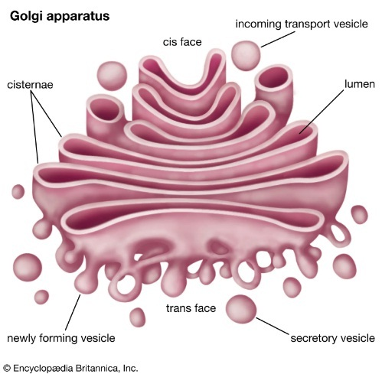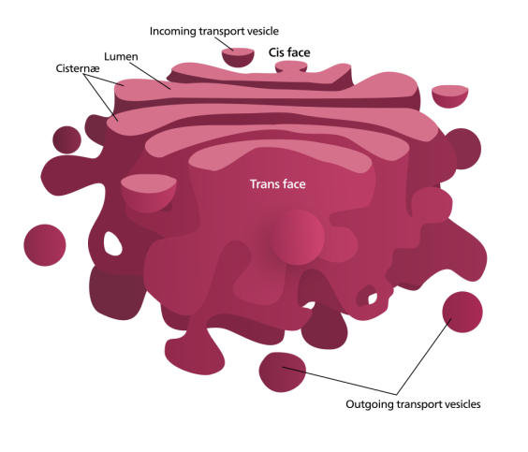

The Golgi apparatus, also known as the Golgi complex, is a crucial organelle in eukaryotic cells that acts as a packaging and distribution center for biomolecules like proteins and lipids. It's responsible for modifying, sorting, and packaging these molecules, ultimately directing them to their final destinations within or outside the cell.
Here's a more detailed look:
Structure:
- The Golgi apparatus is a stack of flattened, membrane-enclosed sacs called cisternae.
- These stacks, called Golgi stacks, are usually made of 4 to 8 cisternae, although some cells can have up to 60.
- In animal cells, multiple stacks are connected by tubules, forming a single complex.
- The Golgi apparatus is typically located near the nucleus and centrosome in animal cells, a position that depends on microtubules.
Function:
- Modifying Proteins:
The Golgi apparatus receives proteins from the endoplasmic reticulum (ER) and further processes them, adding or removing sugars (glycosylation) and other modifications.
- Sorting and Packaging:
It sorts proteins and lipids, packaging them into vesicles for transport to their destinations.
- Lysosome Formation:
The Golgi apparatus plays a role in the formation of lysosomes, which contain digestive enzymes.
- Secretory Pathway:
It's a key part of the secretory pathway, responsible for delivering proteins and lipids to various destinations, including the cell membrane and lysosomes.
- Cell Wall Synthesis (in plant cells):
In plant cells, the Golgi apparatus synthesizes the complex polysaccharides that make up the cell wall.
Importance:
- The Golgi apparatus is essential for cellular homeostasis and protein trafficking.
- Dysfunction of the Golgi apparatus can lead to various diseases.
- The Golgi apparatus is crucial for cell polarity, which is the process by which a cell defines an oriented axis.

lysosome
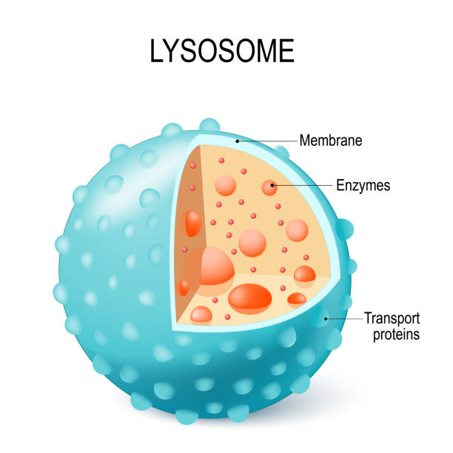
Lysosomes are membrane-bound organelles that function as the cell's digestive system, responsible for breaking down waste materials and cellular debris. They contain powerful hydrolytic enzymes that can degrade various biological polymers like proteins, carbohydrates, lipids, and nucleic acids. Lysosomes also play a role in recycling cellular components and can even be involved in programmed cell death (apoptosis).
Key Functions of Lysosomes:
- Intracellular Digestion: Lysosomes break down materials taken up from outside the cell (via endocytosis and phagocytosis) and internal cellular waste.
- Recycling: The building blocks released during digestion can be reused by the cell.
- Cellular Defense: Lysosomes help defend against pathogens by engulfing and digesting them.
- Apoptosis: Lysosomes can be involved in programmed cell death, where the cell disposes of its own components.
Structure and Composition:
- Lysosomes are spherical, membrane-bound vesicles containing a variety of hydrolytic enzymes.
- The enzymes are synthesized in the endoplasmic reticulum and modified in the Golgi complex before being transported to the lysosomes.
- The lysosomal membrane has a specialized vacuolar H+-ATPase (v-ATPase) that maintains the acidic pH inside the lysosome, which is necessary for the optimal activity of the enzymes.
Types of Lysosomes:
- Primary lysosomes:
Newly formed lysosomes containing undigested materials.
- Secondary lysosomes:
Formed when primary lysosomes fuse with vacuoles containing material to be digested.
- Residual bodies:
Lysosomes that remain after digestion and may contain indigestible materials.
- Autophagic vacuoles:
Lysosomes involved in the digestion of intracellular material through autophagy.
Lysosomes and Diseases:
- Lysosomal storage disorders can occur due to mutations in genes that encode lysosomal enzymes, leading to the accumulation of undigested material in lysosomes.
- Dysfunction of lysosomes has also been implicated in various diseases, including inflammatory and autoimmune disorders, neurodegenerative diseases, and cancer.

Vacuoles
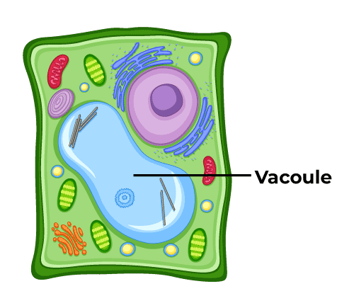

Vacuoles are membrane-bound organelles found in various cell types, including plant and animal cells, and they play a crucial role in storage, waste disposal, and maintaining cell turgor. Plant cells typically have large, central vacuoles, while animal cells have smaller vacuoles that may be specialized for different functions.
Here's a more detailed look at vacuoles:
1. Structure:
- Membrane-bound: Vacuoles are enclosed by a membrane called the tonoplast.
- Fluid-filled: They contain a watery fluid called cell sap, which can hold a variety of substances.
- Size: Vacuoles vary in size depending on the cell type. In plant cells, the vacuole can occupy a large portion of the cell's volume, often exceeding 80%.
- Number: Cells can have one large vacuole or multiple smaller vacuoles.
2. Functions:
- Storage: Vacuoles store water, nutrients, waste products, and other molecules.
- Waste disposal: They help to sequester and eliminate waste products from the cell.
- Turgor pressure: In plant cells, vacuoles play a crucial role in maintaining cell turgor pressure, which is important for cell growth and providing structural support.
- Protection: Vacuoles can protect the cell from harmful substances by sequestering them within the vacuole.
- Other specialized functions: In some organisms, vacuoles have specialized functions, such as digesting food in protists or regulating buoyancy in bacteria.
3. Types of Vacuoles:
- Plant vacuoles: Large, central vacuoles that store water, nutrients, and waste products.
- Animal vacuoles: Smaller vacuoles that may be specialized for waste disposal or other functions.
- Food vacuoles: Found in protists, used for storing and digesting food.
- Contractile vacuoles: Found in some protists, used for regulating water balance.
- Gas vacuoles: Found in some bacteria, used for buoyancy.
4. Importance in Plant Cells:
- Structural support:
Vacuoles contribute to the plant cell's structural integrity by maintaining turgor pressure.
- Growth and development:
They play a role in plant growth and development, including processes like cell enlargement.
- Metabolism:
Vacuoles are involved in various metabolic processes, including the storage and transport of substances.
- Response to stress:
Vacuoles play a role in plant responses to environmental stresses, such as drought or salinity.

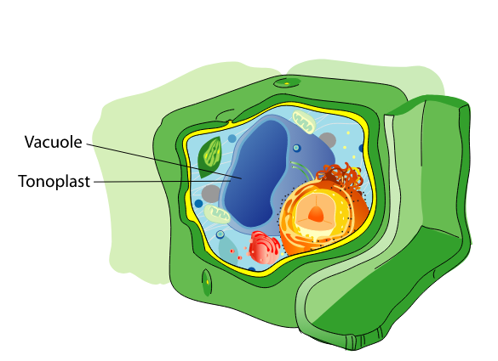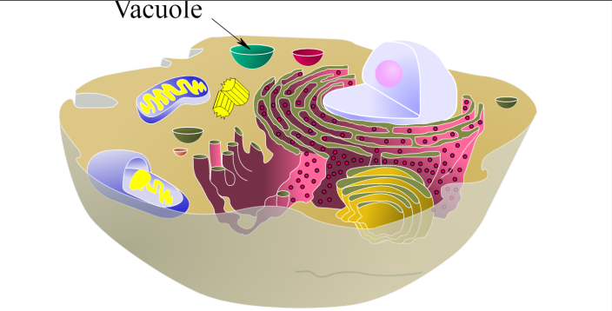
Plant Vacuole Animal Vacuole

mitochondria

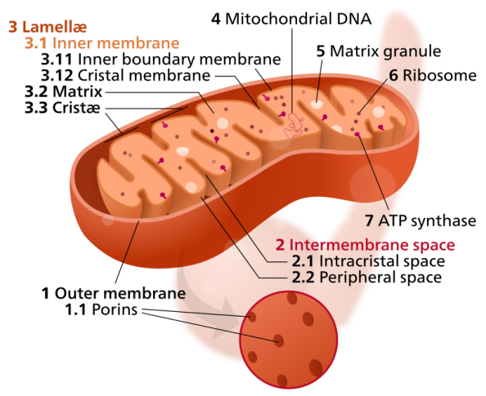

Mitochondria, often called the "powerhouse of the cell," are double-membrane-bound organelles responsible for generating most of the chemical energy needed to power a cell's biochemical reactions. This energy is stored in ATP (adenosine triphosphate), a small molecule. They are found in most eukaryotic organisms, including animals, plants, and fungi.
Here's a more detailed look:
- Function:
Mitochondria primarily generate ATP through cellular respiration, which involves breaking down glucose and other molecules to release energy.
- Structure:
They have a double membrane structure, with an outer and inner membrane, and an intermembrane space. The inner membrane has folds called cristae, which increase surface area for ATP production.
- Location:
They are found in the cytoplasm of eukaryotic cells.
- Importance:
Mitochondria play a crucial role in energy production, and their proper functioning is essential for cell health and survival.
- Unique Features:
Mitochondria have their own DNA and can reproduce independently of the cell, suggesting an ancient origin as free-living prokaryotes.

Plastids
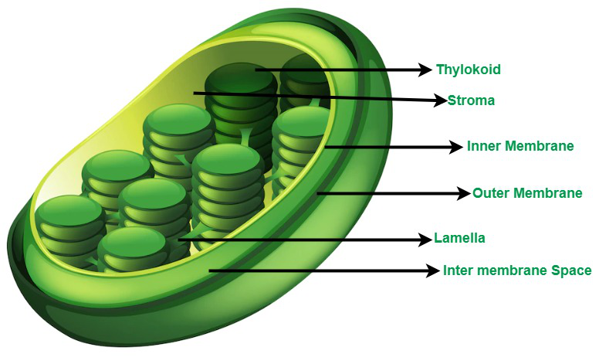
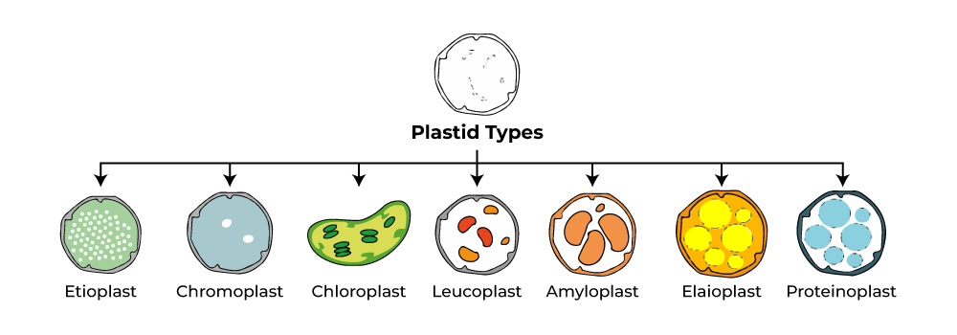
Plastids are double-membrane-bound organelles found in plant and algal cells, acting as the site for photosynthesis, food storage, and pigment production. They are diverse, including chloroplasts (green, photosynthetic), chromoplasts (pigment-containing), and leucoplasts (colorless, storage). Plastids are believed to have originated from endosymbiotic events involving photosynthetic bacteria.
Here's a more detailed look:
Key Features of Plastids:
- Double Membrane:
Like mitochondria, plastids have two membranes, an inner and an outer, surrounding their structure.
- Own DNA and Ribosomes:
Plastids possess their own DNA and ribosomes, indicating a semi-autonomous nature.
- Diverse Functions:
They perform a variety of roles, including photosynthesis, storage of starch and other compounds, and pigment synthesis, which gives plants their color.
Types of Plastids:
- Chloroplasts:
The most well-known type, responsible for photosynthesis, containing chlorophyll for light capture.
- Chromoplasts:
Contain pigments other than chlorophyll, giving colors to fruits, flowers, and other plant parts.
- Leucoplasts:
Colorless plastids that store starch (amyloplasts), lipids (elaioplasts), or proteins (proteinoplasts).
- Gerontoplasts:
Chloroplasts that have been modified for plastid recycling during senescence or stress.
- Proplastids:
Undifferentiated plastids that can develop into different types of mature plastids.
- Etioplasts:
Plastids that develop in the absence of light.

nucleus
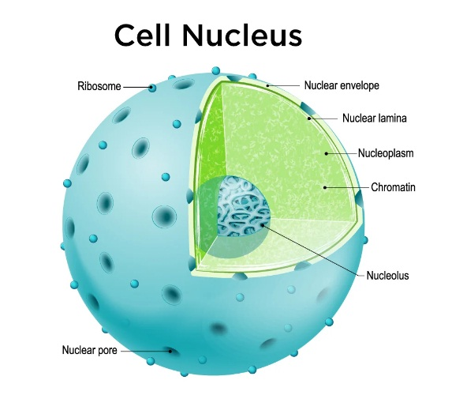
The nucleus is the control center of a eukaryotic cell, containing the cell's genetic material (DNA) organized into chromosomes. It's a double-membrane-bound organelle that separates the genetic material from the cytoplasm, allowing for regulation of gene expression. The nucleus is responsible for DNA replication, transcription, RNA processing, and regulating gene expression.
Here's a more detailed look at the nucleus:
- Location and Structure:
The nucleus is typically located near the center of the cell and is enclosed by a double membrane called the nuclear envelope. This envelope has pores that allow for the transport of molecules between the nucleus and the cytoplasm.
- Genetic Material:
The nucleus contains the cell's DNA, organized into chromosomes. DNA is the blueprint for all cellular activities.
- Key Functions:
The nucleus plays a crucial role in:
  - DNA Replication: Duplicating the genetic material before cell division.
  - Transcription: Converting DNA into RNA, a crucial step in gene expression.
  - RNA Processing: Modifying RNA before it's transported out of the nucleus.
  - Regulation of Gene Expression: Controlling which genes are turned on or off, allowing the cell to specialize and respond to its environment.
- Compartmentalization:
The nucleus provides a distinct compartment for the cell's genetic material, separating it from other cellular processes in the cytoplasm. This compartmentalization allows for more efficient regulation of gene expression.
- Size and Shape:
The nucleus is the largest organelle in most cells, typically spherical or oblong.
- Prokaryotic vs. Eukaryotic:
Unlike prokaryotic cells, which lack a nucleus, eukaryotic cells have a membrane-bound nucleus.

plasma membrane
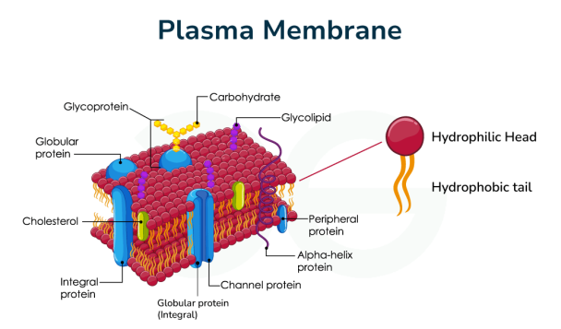

The plasma membrane, also known as the cell membrane, is a crucial structure in all living cells that separates the cell's interior from its external environment. It's a semipermeable barrier that regulates the movement of substances into and out of the cell, acting as a selective gateway for nutrients, waste, and other materials.
Key Features and Functions:
- Structure: Primarily composed of a phospholipid bilayer, with embedded proteins and carbohydrates.
- Selective Permeability: Allows the passage of certain molecules while preventing others, ensuring the cell's internal environment remains stable.
- Cellular Boundaries: Forms the outermost boundary of the cell, separating it from the outside world.
- Transport: Regulates the movement of substances across the membrane, both into and out of the cell.
- Communication: Plays a role in cell signaling and communication with other cells.
- Cell Shape and Stability: Helps maintain the cell's overall structure and shape.

Nuclear mEMBRANE

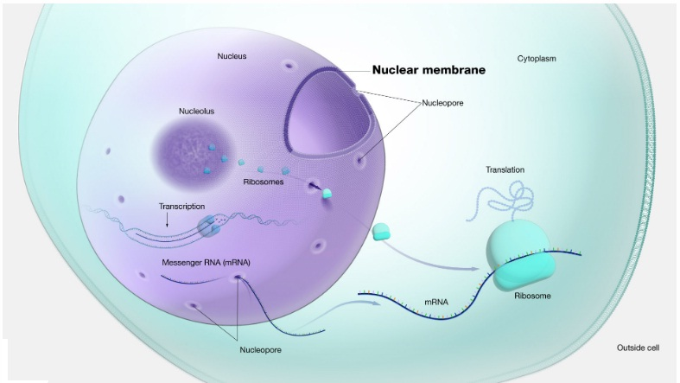

The nuclear membrane, also known as the nuclear envelope, is a double-layered membrane that encloses the nucleus in eukaryotic cells. It separates the contents of the nucleus from the cytoplasm and regulates the movement of molecules in and out. The nuclear envelope consists of an outer and inner membrane with a space between them called the perinuclear space, which connects to the endoplasmic reticulum.
Here's a more detailed look:
- Function:
The nuclear membrane acts as a barrier, preventing the free passage of molecules between the nucleus and the cytoplasm. It also plays a role in regulating gene expression and DNA replication.
- Structure:
  - Outer Nuclear Membrane: This membrane is continuous with the endoplasmic reticulum and may have ribosomes attached to its surface.
  - Inner Nuclear Membrane: This membrane is lined with a network of proteins called the nuclear lamina, which helps maintain the shape of the nucleus.
  - Perinuclear Space: The space between the two membranes is connected to the endoplasmic reticulum and contains a variety of proteins and other molecules.
  - Nuclear Pores: These are channels that allow the controlled passage of molecules, such as proteins and RNA, between the nucleus and the cytoplasm. They are formed by large protein complexes called nuclear pore complexes (NPCs).
- Key Features:
  - Selective Permeability: The nuclear membrane is selectively permeable, meaning that it allows only specific molecules to pass through.
  - Nuclear Lamina: The nuclear lamina, composed of proteins like lamins, provides structural support and is involved in processes like chromosome organization and DNA repair.
  - Nuclear Pore Complexes (NPCs): These structures regulate the movement of molecules between the nucleus and the cytoplasm.
- Comparison to Cell Membrane:
While both the nuclear membrane and the cell membrane are composed of lipid bilayers, they have distinct functions. The cell membrane surrounds the entire cell, while the nuclear membrane surrounds the nucleus, which contains the genetic material.

protoplasm

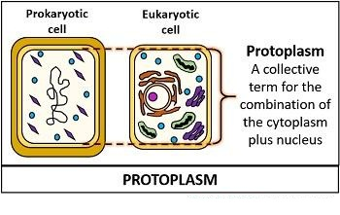
Protoplasm is the living substance inside a cell, encompassing all the cellular components within the plasma membrane. It includes the cytoplasm, the nucleus, and all the organelles suspended within the cytoplasm. Essentially, protoplasm represents the "living" part of the cell, distinct from the cell wall in plant cells or the surrounding membrane in animal cells.
Key components of protoplasm:
- Cytoplasm: The fluid within the cell that houses the organelles.
- Nucleus: The control center of the cell, containing the genetic material (DNA).
- Organelles: Specialized structures within the cytoplasm that perform specific functions, such as ribosomes, mitochondria, and vacuoles.
In simpler terms: Protoplasm is the jelly-like substance inside a cell where all the cell's activities take place, like in a small factory where different "machines" (organelles) work to keep the cell alive.

cytoplasm
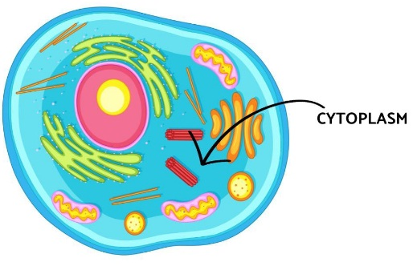
Cytoplasm is the gelatinous liquid that fills the inside of a cell. It is composed of water, salts, and various organic molecules. Some intracellular organelles, such the nucleus and mitochondria, are enclosed by membranes that separate them from the cytoplasm.

centriole
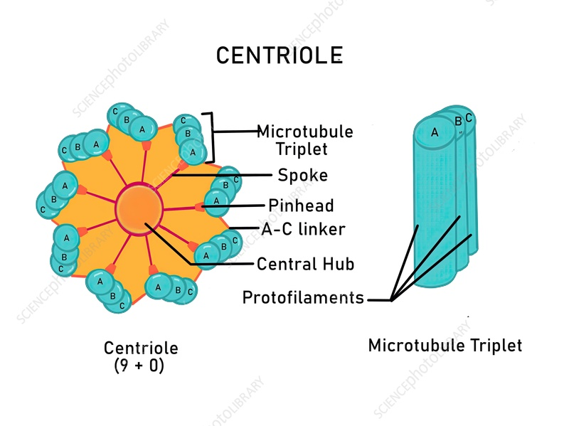

A centriole is a cylindrical organelle primarily made of the protein tubulin, found in most eukaryotic cells but not in plants, conifer, or flowering plants. It plays a crucial role in cell division and is involved in the formation of cilia and flagella, structures that enable movement and sensing in some cells.
Here's a more detailed breakdown:
Structure and Function:
- Location:
Centrioles are located in the cytoplasm, usually near the nucleus, and are part of a larger structure called the centrosome.
- Composition:
They are cylindrical and composed of nine triplets of microtubules, forming a barrel-shaped structure.
- Role in Cell Division:
Centrioles are essential for organizing microtubules, which are the cell's skeletal system, and are crucial for cell division.
- Formation of Cilia and Flagella:
In some cells, centrioles act as the basal body, the structure from which cilia and flagella originate, allowing the cell to move or sense its environment.
- Centrosome:
The centrosome, containing the centrioles, duplicates before cell division, ensuring that each daughter cell receives a functional centrosome.
In essence, centrioles are important for:
- Organizing microtubules: These microtubules are involved in cell shape, movement, and the segregation of chromosomes during cell division.
- Forming cilia and flagella: These structures are essential for cell movement and sensory functions.
- Ensuring proper cell division: The centrosome, including the centrioles, plays a vital role in the orderly division of cells.

centrosome
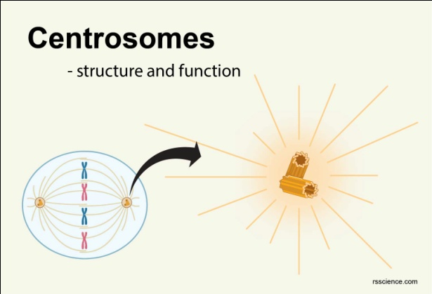
A centrosome is a cellular organelle crucial for cell division in animal cells. It functions as the primary microtubule-organizing center (MTOC), playing a key role in organizing microtubules and facilitating cell motility, adhesion, and polarity. During cell division, the centrosome duplicates, and the two resulting centrosomes migrate to opposite ends of the cell, where they help form the mitotic spindle, ensuring proper chromosome segregation.
Here's a more detailed explanation:
Structure and Function:
- Microtubule Organization:
The centrosome is a complex structure that includes two centrioles and the surrounding pericentriolar material (PCM). The PCM is a matrix of proteins that nucleate and organize microtubules.
- Cell Cycle Regulation:
The centrosome plays a vital role in the cell cycle, particularly during cell division. It duplicates during the S phase and then guides the formation of the mitotic spindle during mitosis.
- Chromosome Segregation:
The centrosome's primary function is to ensure accurate chromosome segregation during cell division. The two centrosomes move to opposite poles of the cell, and the microtubules emanating from them form the mitotic spindle, which pulls the chromosomes apart into daughter cells.
- Other Roles:
In addition to its role in cell division, the centrosome is also involved in other cellular processes, such as cell motility, adhesion, and the organization of cilia and flagella.
Centrosome and Mitosis:
- Duplication: Before cell division, the centrosome duplicates, resulting in two centrosomes.
- Spindle Formation: These duplicated centrosomes move to opposite ends of the cell.
- Microtubule Organization: The centrosomes then organize microtubules into a spindle that connects to the chromosomes.
- Chromosome Segregation: The spindle fibers pull the chromosomes apart into the two daughter cells.
- Nuclear Envelope Breakdown and Reformation: The centrosome also plays a role in the breakdown of the nuclear envelope during prophase and the reformation of the nuclear envelope during telophase.
Variations and Evolution:
- Evolutionary Conservation:
The centrosome is found in most eukaryotic cells, but it is particularly well-studied in animal cells.
- Variations in Structure:
While the basic structure of a centrosome is conserved, there can be variations in its composition and function depending on the cell type and species.
- Absence in Some Organisms:
Some organisms, like fungi and plants, lack centrosomes altogether and use other structures to organize their microtubules.

